**MDA d YOUNG ACHIEVERS PROGRAM   
Project Proposal**

Team BLE  
  
Tan Jin Chun (32194471)  
Chong Yen Juin (32259417)  
Chung Chin Leon (33067090)  
  
Monash University Malaysia  
School of Engineering  
Electrical and Computer System Engineering (ECSE)

**Background and Objective**



Our Bluetooth Low Energy (BLE)-powered advertising app tackles digital ad saturation, where excessive online advertisement loses their impact. This saturated environment not only frustrates users but also places businesses in a precarious position, as they struggle to ensure their advertising dollars yield tangible results. Our initiative aims to cut through this digital noise by offering a solution that benefits both consumers and businesses. Targeting local businesses and their potential customers, our objective is to enhance user engagement with ads that are both relevant and timely, using engagement rates and conversion metrics as key indicators of success. This approach promises a win-win: consumers enjoy a more personalised browsing experience and businesses achieve a higher return on investment from their advertising efforts.

**Idea and Technology**

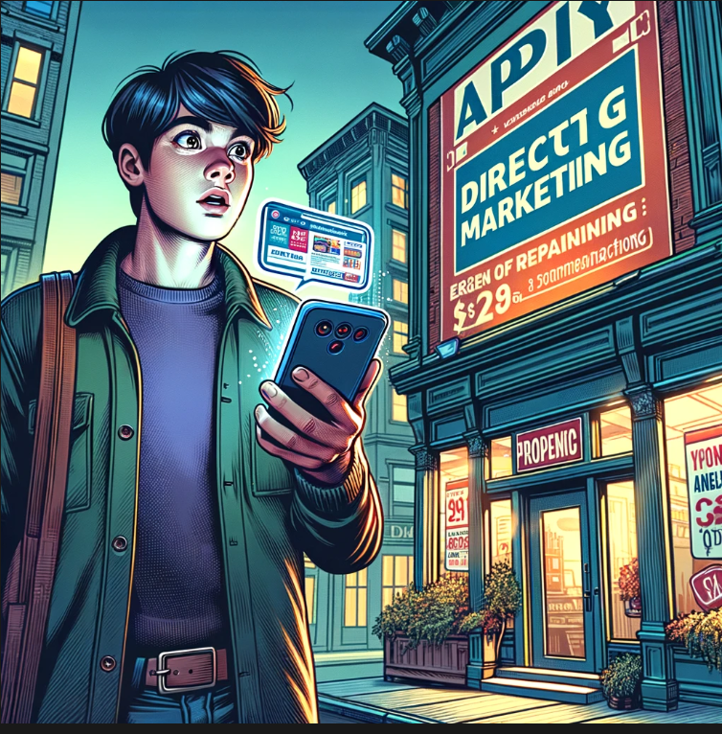

Leveraging BLE technology's low energy requirements and precise proximity capabilities, our app redefines local marketing. It ensures that promotions are not only timely and pertinent but also reach potential customers at the optimal moment—when they're physically close to the offering. This approach significantly boosts engagement, as consumers receive promotions that genuinely interest them and offers businesses a smarter way to reach their audience, avoiding the scattergun approach of traditional digital advertising. While with permission, users’ data record may be sent to the business premise for personalised ads.

**Impact and Scalability**

To maximise impact and ensure scalability, we'll focus on forging strong partnerships with local businesses and retail chains, incorporating our service into their operations seamlessly. By highlighting the personalization and exclusive benefits to consumers, alongside showcasing success stories to businesses, we'll drive adoption and foster a network effect. Continuous technological refinement and adaptation to evolving market demands will underpin our strategy for widespread implementation and sustained growth, transforming how businesses connect with their customers and setting a new standard in targeted advertising.